**Scenario #1**

Testing Scenarios

* Accelerometer and compass
  + Input code in microbit that constantly returns the compass heading.
  + Input code in microbit that constantly returns the acceleration.

Test Results

* The output for the compass heading is an integer value in degrees with 1 - 3 digits (0 - 359)
* The output for the acceleration is an integer value in m/s^2.
* Acceleration output can be programmed in any plane (x, y, z), and can also be summarized in a general strength value.

**Scenario #2**

Testing Scenarios

* Onboard temperature sensing in warm and cold environments
  + When “A” button is pressed, the temperature will be displayed.
  + Tester can place microbit in the desired location (dorm room, fridge, outdoor garage, in direct sunlight, shade etc.), and get a temperature reading.
* Battery life for 24 hours and in cold temperatures
  + The microbit will send a radio frequency communication while simultaneously displaying a LED “Happy Face.”
  + When the LEDs are no longer lit, this will signal the end of battery life.
  + Tester can place microbit in the desired location (dorm room, fridge, outdoor garage, etc.) to test battery life in a variety of temperatures.

Test Results

* The output for the temperature sensor is an integer value in degrees celsius
* The microbit wasn’t too accurate in the cold outdoor weather with the output being between 1°C to 6°C with the average of 3.25°Cwhile the weather app indicated that it was -3 °C and -2 °C with the “feels like” being -8°C. (in front of Saint johns)
* The microbit performed well in doors. The thermometer in eppley indicated that it was 71°F which is 21.667 °C and the microbit’s output ranged from 20°C to 22°C with an average of 21.23°C.
* The microbit lasted longer than 24 hours with the script. I stopped it at 24 hours but I found a chart that laid out the complete battery life with different types of batteries. (Below)
  + 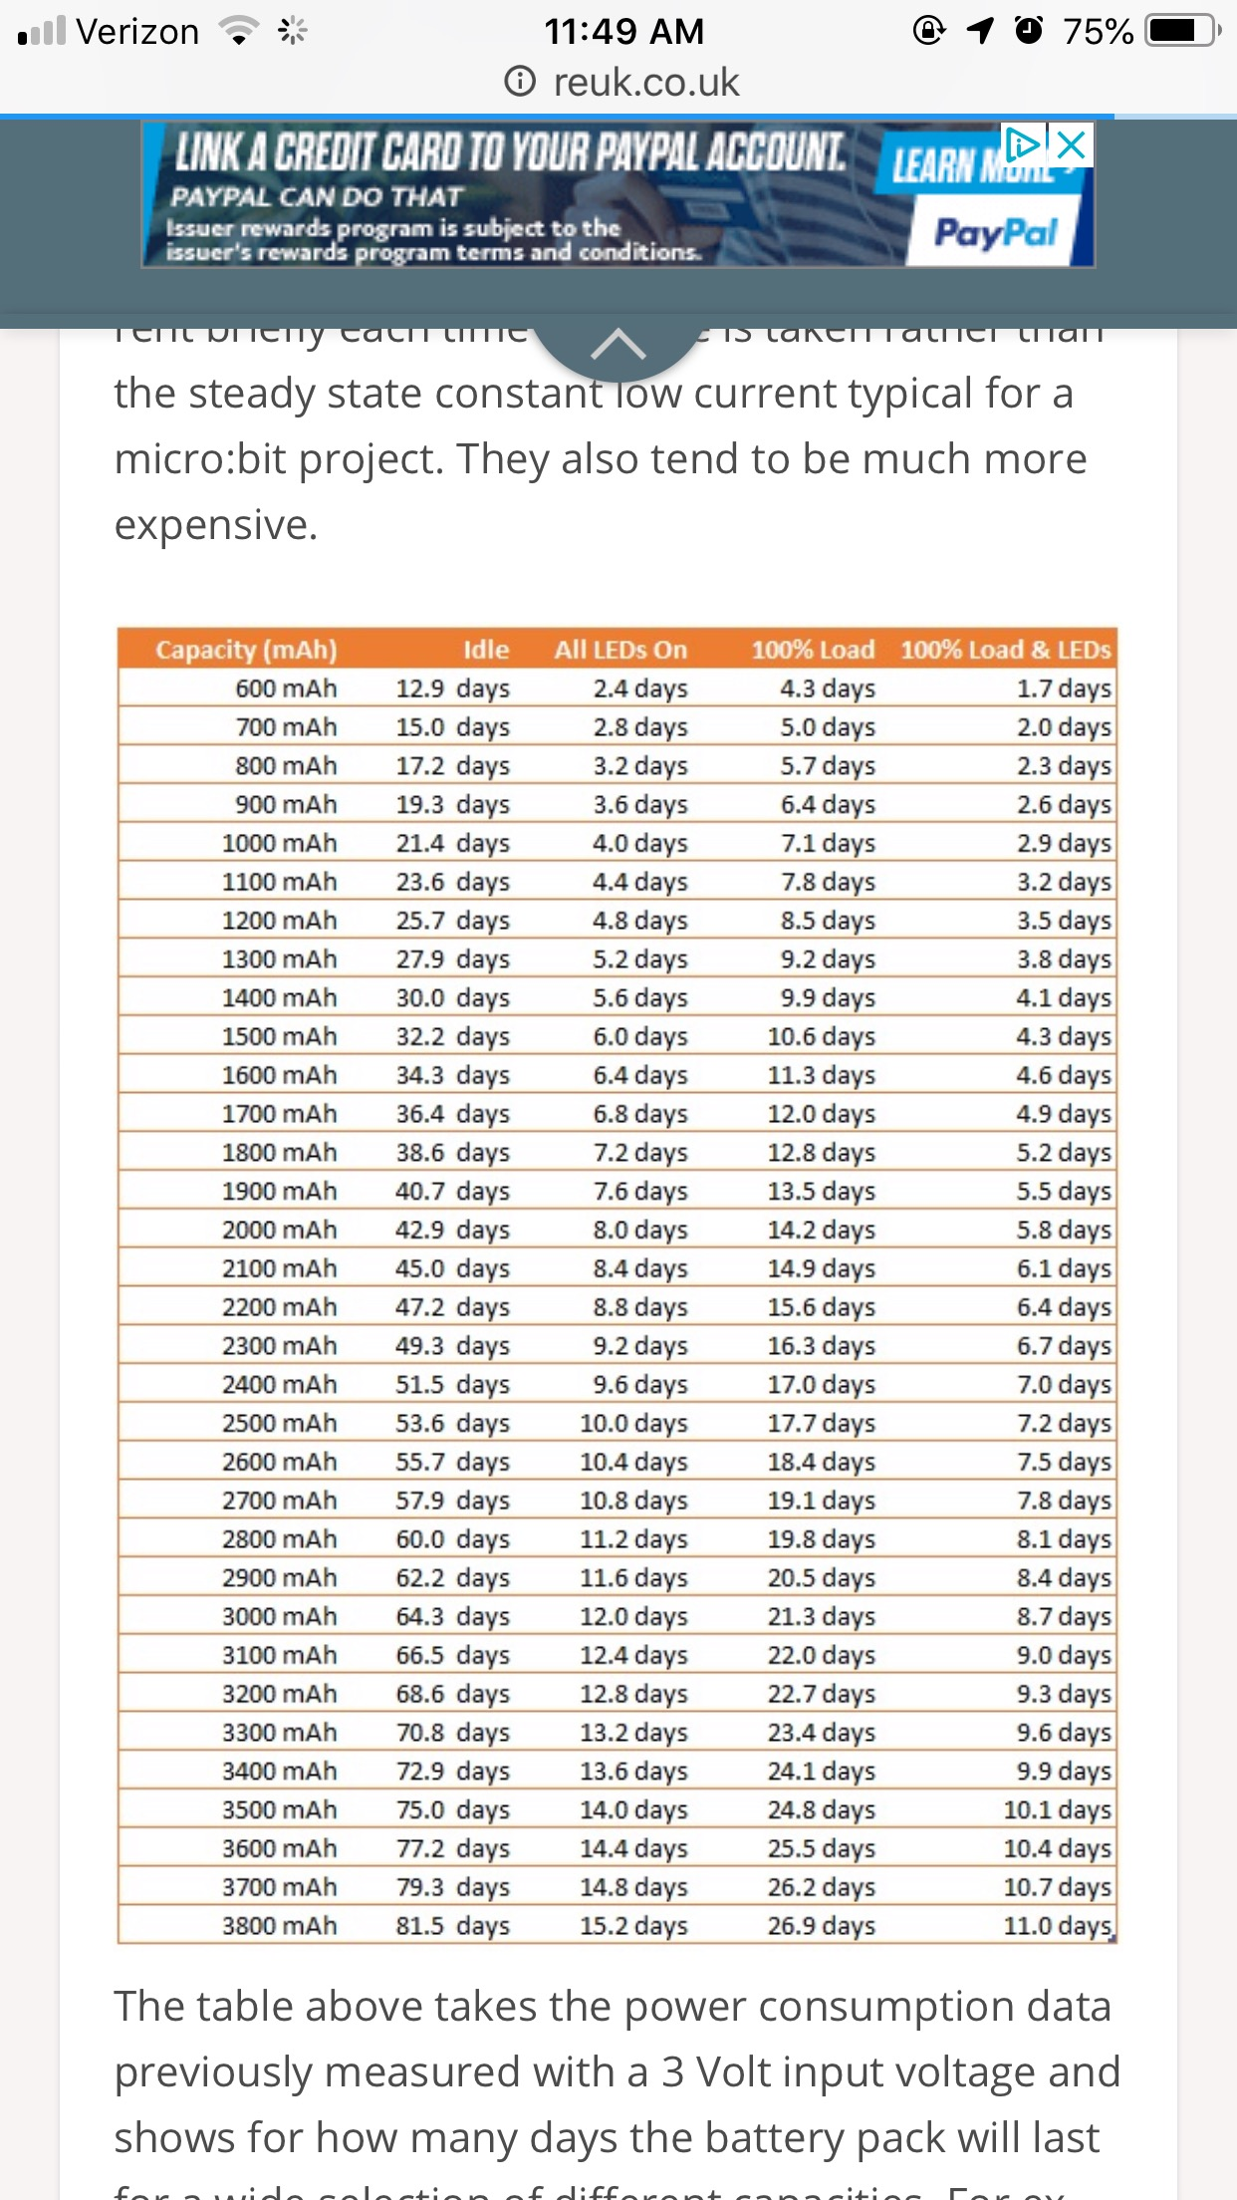

**Scenario #3**

Testing Scenarios

* Maximum distance of microbit radio communication (Networking Group)
  + Two microbits were programmed to send radio communications to each other.
  + Two users, each holding one of the microbits slowly back away from each other until communication stops
* Microbit internal clock adjustments
  + Program microbit to constantly display temperature setting in a while loop, but pause for a certain amount of time.
  + User can adjust pause limit (in ms) and the mirobit will only display the temperature after pause time.
* Infrared sensor output
  + David will be testing the infrared sensor when connected to the microbit
* Battery life in the cold (See documentation and test results for scenario #2)

Test Results

* Microbits can send radio signals at a maximum distance of about 50 feet.
* Microbit can be programmed to pause for a few hundred milliseconds to a custom value. The value must be in milliseconds. It may be beneficial to record constantly, but only log certain data points.
* The output for the infrared sensor is an integer value between 0 - 1023 where 0 = 0V and 1023 = 3.3V.
* The microbit performed very well in the cold. It was 38 degrees fahrenheit outside. I tested it on 2 hour intervals and it did not turn off from battery issues.